|  |  |
| --- | --- |
| [TGBT-4] [Trivia game questions do not appear in a random order once clicking on "try again" button in the results page](https://guy121212.atlassian.net/browse/TGBT-4) Created: 07/Aug/22  Updated: 07/Aug/22 | |
| **Status:** | To Do |
| **Project:** | [TRIVIA Game - Bug Tracking](https://guy121212.atlassian.net/secure/BrowseProject.jspa?id=10002) |
| **Components:** | None |
| **Affects versions:** | None |
| **Fix versions:** | None |

|  |  |  |  |
| --- | --- | --- | --- |
| **Type:** | Bug | **Priority:** | Medium |
| **Reporter:** | [Art Guy](https://guy121212.atlassian.net/secure/ViewProfile.jspa?accountId=70121%3A04fed8cf-9ece-482b-9aa6-81042e5296df) | **Assignee:** | Unassigned |
| **Resolution:** | Unresolved | **Votes:** | 0 |
| **Labels:** | None | | |
| **Remaining Estimate:** | Not Specified | | |
| **Time Spent:** | Not Specified | | |
| **Original estimate:** | Not Specified | | |

|  |  |
| --- | --- |
| **Severity:** | High |

|  |  |
| --- | --- |
| **Description** |  |

|  |
| --- |
| Steps:   1. login to <https://shemsvcollege.github.io/Trivia/> 2. Click on the "start" button 3. Fill in "Do cats usually land on their feet?" in 1st question field 4. Click "next" button 5. Type "Yes" in 1st answer field 6. Type "No" in 2nd answer field 7. Type "Maybe" in 3rd answer field 8. Type "Nobody knows" in 4th answer field 9. Mark the radio button next to the 1st answer ("Yes") 10. Click on "next" button 11. Fill in "How many wheels does a car have?" 12. Click "next" button 13. Type "1" in 1st answer field 14. Type "2" in 1st answer field 15. Type "3" in 1st answer field 16. Type "4" in 1st answer field 17. Mark the radio button next to the 4th answer ("4") 18. Click "next" button 19. Fill in "What is the color of a tomato?" in 3rd question field 20. Click "next" button 21. Type "Green" in 1st answer field 22. Type "Blue" in 2nd answer field 23. Type "Red" in 3rd answer field 24. Type "Yellow" in 4th answer field 25. Mark the radio button next to the 3rd answer ("Red") 26. Click "next" button 27. Click "play" button 28. Click on radio button next to the 3rd question "Red" 29. Click "next" button 30. Mark the radio button next to the 4th answer ("4") 31. Click "next" button 32. Click on radio button next to the 1st question "Yes" 33. Click "next" button 34. Click “try again” button   Expected result:  Test page with one of the questions appears randomly followed by the rest of the questions in an overall random order  Actual result:  Questions appear in backward order from the order in which they were filled in the Creation phase and not just randomly (3,2,1)  Notes:  Same result happened many times and the order of the questions repeated itself |

|  |  |
| --- | --- |
| [TGBT-3] [Trivia game results would not be shared on Facebook when clicking on the "share on facebook" button](https://guy121212.atlassian.net/browse/TGBT-3) Created: 07/Aug/22  Updated: 07/Aug/22 | |
| **Status:** | To Do |
| **Project:** | [TRIVIA Game - Bug Tracking](https://guy121212.atlassian.net/secure/BrowseProject.jspa?id=10002) |
| **Components:** | None |
| **Affects versions:** | None |
| **Fix versions:** | None |

|  |  |  |  |
| --- | --- | --- | --- |
| **Type:** | Bug | **Priority:** | High |
| **Reporter:** | [Art Guy](https://guy121212.atlassian.net/secure/ViewProfile.jspa?accountId=70121%3A04fed8cf-9ece-482b-9aa6-81042e5296df) | **Assignee:** | Unassigned |
| **Resolution:** | Unresolved | **Votes:** | 0 |
| **Labels:** | None | | |
| **Remaining Estimate:** | Not Specified | | |
| **Time Spent:** | Not Specified | | |
| **Original estimate:** | Not Specified | | |

|  |  |
| --- | --- |
| **Severity:** | High |

|  |  |
| --- | --- |
| **Description** |  |

|  |
| --- |
| Steps:   1. login to <https://shemsvcollege.github.io/Trivia/> 2. Click on the "start" button 3. Fill in "Do cats usually land on their feet?" in 1st question field 4. Click "next" button 5. Type "Yes" in 1st answer field 6. Type "No" in 2nd answer field 7. Type "Maybe" in 3rd answer field 8. Type "Nobody knows" in 4th answer field 9. Mark the radio button next to the 1st answer ("Yes") 10. Click on "next" button 11. Fill in "How many wheels does a car have?" 12. Click "next" button 13. Type "1" in 1st answer field 14. Type "2" in 1st answer field 15. Type "3" in 1st answer field 16. Type "4" in 1st answer field 17. Mark the radio button next to the 4th answer ("4") 18. Click "next" button 19. Fill in "What is the color of a tomato?" in 3rd question field 20. Click "next" button 21. Type "Green" in 1st answer field 22. Type "Blue" in 2nd answer field 23. Type "Red" in 3rd answer field 24. Type "Yellow" in 4th answer field 25. Mark the radio button next to the 3rd answer ("Red") 26. Click "next" button 27. Click "play" button 28. Click on radio button next to the 3rd question "Red" 29. Click "next" button 30. Mark the radio button next to the 4th answer ("4") 31. Click "next" button 32. Click on radio button next to the 1st question "Yes" 33. Click "next" button 34. Click "Share on Facebook" button   Expected result:  Result is shared on facebook  Actual result:  Once click on the “Share” button, a pop-up window appears with a message: "Would you like to exit the website? the changes you made may not be saved", an "Exit" button and "Cancel" button. Once click on the "Exit" button a 404 error page appears.  Notes:  The “Cancel” button just closes the pop-up window |

|  |  |
| --- | --- |
| [TGBT-2] [Trivia game solved with 1 answer wrong still shows as a success in results page](https://guy121212.atlassian.net/browse/TGBT-2) Created: 07/Aug/22  Updated: 07/Aug/22 | |
| **Status:** | To Do |
| **Project:** | [TRIVIA Game - Bug Tracking](https://guy121212.atlassian.net/secure/BrowseProject.jspa?id=10002) |
| **Components:** | None |
| **Affects versions:** | None |
| **Fix versions:** | None |

|  |  |  |  |
| --- | --- | --- | --- |
| **Type:** | Bug | **Priority:** | High |
| **Reporter:** | [Art Guy](https://guy121212.atlassian.net/secure/ViewProfile.jspa?accountId=70121%3A04fed8cf-9ece-482b-9aa6-81042e5296df) | **Assignee:** | Unassigned |
| **Resolution:** | Unresolved | **Votes:** | 0 |
| **Labels:** | None | | |
| **Remaining Estimate:** | Not Specified | | |
| **Time Spent:** | Not Specified | | |
| **Original estimate:** | Not Specified | | |

|  |  |
| --- | --- |
| **Severity:** | High |

|  |  |
| --- | --- |
| **Description** |  |

|  |
| --- |
| Steps:   1. login to <https://shemsvcollege.github.io/Trivia/> 2. Click on "start" button 3. Fill in "Do cats usually land on their feet?" in 1st question field 4. Click "next" button 5. Type "Yes" in 1st answer field 6. Type "No" in 2nd answer field 7. Type "Maybe" in 3rd answer field 8. Type "Nobody knows" in 4th answer field 9. Mark the radio button next to the 1st answer ("Yes") 10. Click on "next" button 11. Fill in "How many wheels does a car have?" 12. Click "next" button 13. Type "1" in 1st answer field 14. Type "2" in 1st answer field 15. Type "3" in 1st answer field 16. Type "4" in 1st answer field 17. Mark the radio button next to the 4th answer ("4") 18. Click "next" button 19. Fill in "What is the color of a tomato?" in 3rd question field 20. Click "next" button 21. Type "Green" in 1st answer field 22. Type "Blue" in 2nd answer field 23. Type "Red" in 3rd answer field 24. Type "Yellow" in 4th answer field 25. Mark the radio button next to the 3rd answer ("Red") 26. Click "next" button 27. Click "play" button 28. Click on radio button next to the 3rd question "Red" 29. Click "next" button 30. Mark the radio button next to the 4th answer ("4") 31. Click "next" button 32. Click on radio button next to the 2nd question "No" 33. Click "next" button   Expected Results:   1. Result page with "Failed!!" appears 2. Facebook share button appears 3. "Try again" and "Quit" buttons appear   Actual Results:   1. Result page with "Success!!" appears 2. Facebook share button appears 3. "Try again" and "Quit" buttons appear   Notes:  The same result occurred when failing in the other 2 answers, 1 wrong answer each time |

|  |  |
| --- | --- |
| [TGBT-1] [Trivia game answers filled in foreign language allowed instead of automatically being deleted](https://guy121212.atlassian.net/browse/TGBT-1) Created: 04/Aug/22  Updated: 04/Aug/22 | |
| **Status:** | To Do |
| **Project:** | [TRIVIA Game - Bug Tracking](https://guy121212.atlassian.net/secure/BrowseProject.jspa?id=10002) |
| **Components:** | None |
| **Affects versions:** | None |
| **Fix versions:** | None |

|  |  |  |  |
| --- | --- | --- | --- |
| **Type:** | Bug | **Priority:** | Low |
| **Reporter:** | [Art Guy](https://guy121212.atlassian.net/secure/ViewProfile.jspa?accountId=70121%3A04fed8cf-9ece-482b-9aa6-81042e5296df) | **Assignee:** | Unassigned |
| **Resolution:** | Unresolved | **Votes:** | 0 |
| **Labels:** | None | | |
| **Remaining Estimate:** | Not Specified | | |
| **Time Spent:** | Not Specified | | |
| **Original estimate:** | Not Specified | | |

|  |  |
| --- | --- |
| **Severity:** | Normal |

|  |  |
| --- | --- |
| **Description** |  |

|  |
| --- |
| Steps:   1. login to <https://shemsvcollege.github.io/Trivia/> 2. Click on "start" button. 3. Fill in "Do cats usually land on their feet?" in 1st question field 4. Click "next". 5. Type "כן" in 1st answer field 6. Type "לא" in 2nd answer field 7. Type "אולי" in 3rd answer field 8. Type "לא יודע" in 4th answer field 9. Mark the radio button next to the 1st answer ("כן") 10. Click on "next"   Expected Result:  Answers fields will be deleted and would not redirect to next question.  Actual Result:  The next question page appears with an empty question field to fill in.  Notes:   1. Even when only 1 answer is in foreign language we get the same result   2. No matter which option is chosen as correct (The answer in forign language or english) we get the same result  3. Languages tried: Hebrew, Arabic, Russian |

|  |  |
| --- | --- |
| [STQ-6] [GUI Bug - Responsiveness problem -](https://anna-test.atlassian.net/browse/STQ-6) Created: 06/Aug/22  Updated: 06/Aug/22 | |
| **Status:** | To Do |
| **Project:** | [SV Trivia - QA](https://anna-test.atlassian.net/secure/BrowseProject.jspa?id=10003) |
| **Components:** | None |
| **Affects versions:** | None |
| **Fix versions:** | None |

|  |  |  |  |
| --- | --- | --- | --- |
| **Type:** | Bug | **Priority:** | Medium |
| **Reporter:** | [Anna Sharipkin](https://anna-test.atlassian.net/secure/ViewProfile.jspa?accountId=609d3fa15998a60068fcf1fb) | **Assignee:** | Unassigned |
| **Resolution:** | Unresolved | **Votes:** | 0 |
| **Labels:** | None | | |
| **Remaining Estimate:** | Not Specified | | |
| **Time Spent:** | Not Specified | | |
| **Original estimate:** | Not Specified | | |

|  |  |
| --- | --- |
| **Attachments:** | STQ-6-1.JPG     STQ-6.JPG |
| **Severity:** | Normal |

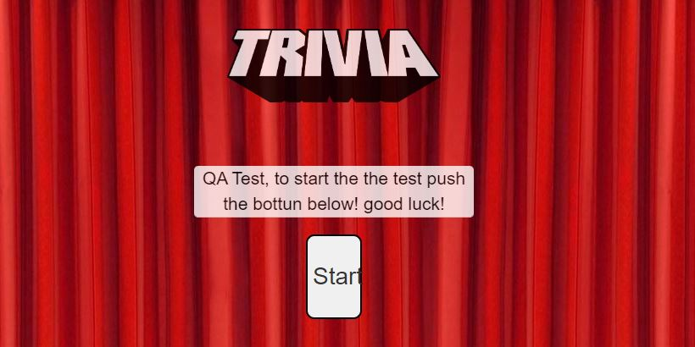



|  |  |
| --- | --- |
| **Description** |  |

|  |
| --- |
| **Steps:**   1. Open the Google Chrome browser 2. Type in the URL bar “<https://shemsvcollege.github.io/Trivia/> ” 3. Click the "Restore down" button in the browser to resize the browser window   **Expected Result:**  Site will adjust itself to the screen size  **Actual Result:**  The web site doesn't know how to change and adapt its shape to the width of the screen. The text goes outside the button's borders.  **Notes:** A bug exists on all pages of the site |

|  |  |
| --- | --- |
| [STQ-5] [GUI Bug - The "Next" button starts with a small letter, and the "Back" button with a capital letter. Inconsistent writing on the site](https://anna-test.atlassian.net/browse/STQ-5) Created: 06/Aug/22  Updated: 06/Aug/22 | |
| **Status:** | To Do |
| **Project:** | [SV Trivia - QA](https://anna-test.atlassian.net/secure/BrowseProject.jspa?id=10003) |
| **Components:** | None |
| **Affects versions:** | None |
| **Fix versions:** | None |

|  |  |  |  |
| --- | --- | --- | --- |
| **Type:** | Bug | **Priority:** | Medium |
| **Reporter:** | [Anna Sharipkin](https://anna-test.atlassian.net/secure/ViewProfile.jspa?accountId=609d3fa15998a60068fcf1fb) | **Assignee:** | Unassigned |
| **Resolution:** | Unresolved | **Votes:** | 0 |
| **Labels:** | None | | |
| **Remaining Estimate:** | Not Specified | | |
| **Time Spent:** | Not Specified | | |
| **Original estimate:** | Not Specified | | |

|  |  |
| --- | --- |
| **Attachments:** | STQ-5.JPG |
| **Severity:** | Normal |

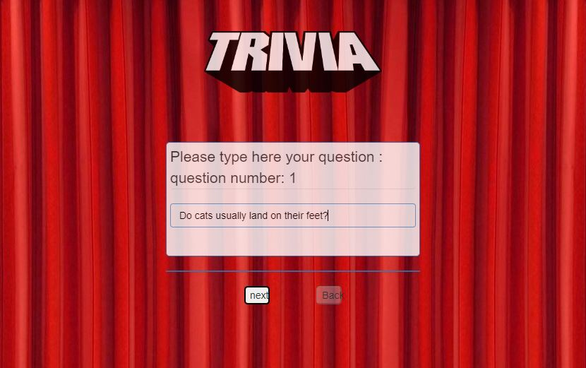

|  |  |
| --- | --- |
| **Description** |  |

|  |
| --- |
| **Steps:**   1. Open the Google Chrome browser 2. Type in the URL bar “<https://shemsvcollege.github.io/Trivia/> ” 3. Click on “Start” button 4. Fill in "Do cats usually land on their feet?" in 1st question field   **Expected Result:**  Buttons with the same design and lettering style  **Actual Result:**  The "Next" button starts with a small letter, and the "Back" button with a capital letter. Inconsistent writing on the site |

|  |  |
| --- | --- |
| [STQ-4] [GUI Bug - A duplicate website background image is printed on the screen several times](https://anna-test.atlassian.net/browse/STQ-4) Created: 06/Aug/22  Updated: 06/Aug/22 | |
| **Status:** | To Do |
| **Project:** | [SV Trivia - QA](https://anna-test.atlassian.net/secure/BrowseProject.jspa?id=10003) |
| **Components:** | None |
| **Affects versions:** | None |
| **Fix versions:** | None |

|  |  |  |  |
| --- | --- | --- | --- |
| **Type:** | Bug | **Priority:** | High |
| **Reporter:** | [Anna Sharipkin](https://anna-test.atlassian.net/secure/ViewProfile.jspa?accountId=609d3fa15998a60068fcf1fb) | **Assignee:** | Unassigned |
| **Resolution:** | Unresolved | **Votes:** | 0 |
| **Labels:** | None | | |
| **Remaining Estimate:** | Not Specified | | |
| **Time Spent:** | Not Specified | | |
| **Original estimate:** | Not Specified | | |

|  |  |
| --- | --- |
| **Attachments:** | STQ-4.JPG |
| **Severity:** | Very High |

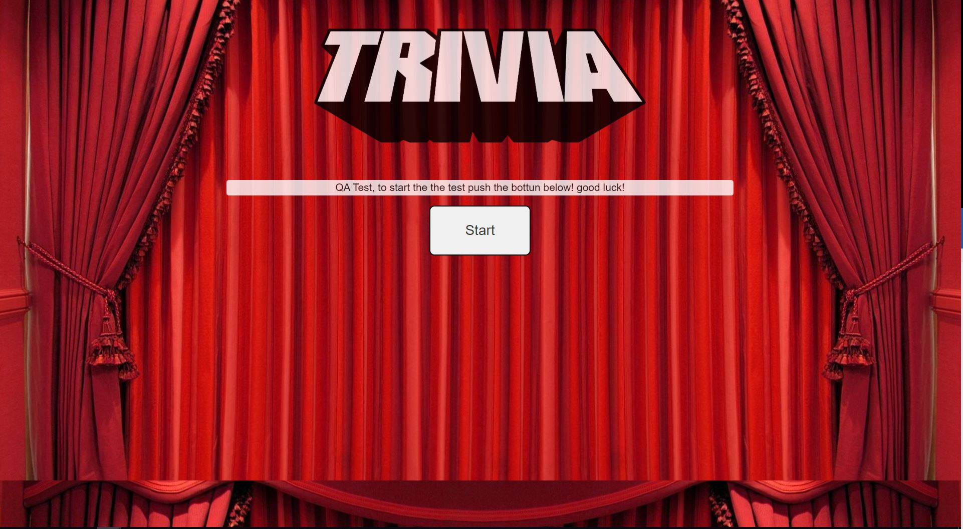

|  |  |
| --- | --- |
| **Description** |  |

|  |
| --- |
| **Steps:**   1. Open the Google Chrome browser 2. Type in the URL bar “<https://shemsvcollege.github.io/Trivia/> ”   **Expected Result:** A background image will fill the entire screen uniformly.  **Actual Result:** A duplicate website background image is printed on the screen several times.  **Notes:** A bug appears on all pages of the application |

|  |  |
| --- | --- |
| [STQ-3] [Question up to 50 characters (not including a question mark)](https://anna-test.atlassian.net/browse/STQ-3) Created: 06/Aug/22  Updated: 06/Aug/22 | |
| **Status:** | To Do |
| **Project:** | [SV Trivia - QA](https://anna-test.atlassian.net/secure/BrowseProject.jspa?id=10003) |
| **Components:** | None |
| **Affects versions:** | None |
| **Fix versions:** | None |

|  |  |  |  |
| --- | --- | --- | --- |
| **Type:** | Bug | **Priority:** | Low |
| **Reporter:** | [Anna Sharipkin](https://anna-test.atlassian.net/secure/ViewProfile.jspa?accountId=609d3fa15998a60068fcf1fb) | **Assignee:** | Unassigned |
| **Resolution:** | Unresolved | **Votes:** | 0 |
| **Labels:** | None | | |
| **Remaining Estimate:** | Not Specified | | |
| **Time Spent:** | Not Specified | | |
| **Original estimate:** | Not Specified | | |

|  |  |
| --- | --- |
| **Severity:** | Low |

|  |  |
| --- | --- |
| **Description** |  |

|  |
| --- |
| **Steps:**   1. Open the Google Chrome browser 2. Type in the URL bar “<https://shemsvcollege.github.io/Trivia/> ” 3. Click on “Start” button 4. Type a question with 50 characters (not include a question mark) "Nam quis nulla. Integer malesuada. In in enim a ar?" in 1st question field 5. Click on “next” button   **Expected Result:**  The question we wrote will appear in the typing field and clicking the “next” button appears Web page : " Please enter 4 possible answers and Mark the right one! question number: 1 "  **Actual Result:**  The content of the field is deleted  **Notes:**  I also tested a 50 character question with a question mark, 50 character question without question mark, 49 character question with question mark. The bug disappears only in a question with exactly 49 characters without a question mark.  There is a bug in the 3 questions |

|  |  |
| --- | --- |
| [STQ-2] [App does not automatically add the question mark in the question](https://anna-test.atlassian.net/browse/STQ-2) Created: 06/Aug/22  Updated: 06/Aug/22 | |
| **Status:** | To Do |
| **Project:** | [SV Trivia - QA](https://anna-test.atlassian.net/secure/BrowseProject.jspa?id=10003) |
| **Components:** | None |
| **Affects versions:** | None |
| **Fix versions:** | None |

|  |  |  |  |
| --- | --- | --- | --- |
| **Type:** | Bug | **Priority:** | Low |
| **Reporter:** | [Anna Sharipkin](https://anna-test.atlassian.net/secure/ViewProfile.jspa?accountId=609d3fa15998a60068fcf1fb) | **Assignee:** | Unassigned |
| **Resolution:** | Unresolved | **Votes:** | 0 |
| **Labels:** | None | | |
| **Remaining Estimate:** | Not Specified | | |
| **Time Spent:** | Not Specified | | |
| **Original estimate:** | Not Specified | | |

|  |  |
| --- | --- |
| **Attachments:** | SRQ-2-2.JPG     SRQ-2-3.JPG     SRQ-2-4.JPG     SRQ-2.JPG |
| **Severity:** | Normal |

|  |  |
| --- | --- |
| **Description** |  |

|  |
| --- |
| **Steps:**   1. Open the Google Chrome browser 2. Type in the URL bar “<https://shemsvcollege.github.io/Trivia/> ” 3. Click on “Start” button 4. Fill in "Do cats usually land on their feet" in 1st question field 5. Click on “next” button 6. Type "Yes" in 1st answer field 7. Type "No" in 2nd answer field 8. Type "Maybe" in 3rd answer field 9. Type "Nobody knows" in 4th answer field 10. Mark the radio button next to the 1st answer ("Yes") 11. Click on “next” button 12. Fill in "How many wheels does a car have" in 2st question field 13. Click on “next” button 14. Type "1" in 1st answer field 15. Type "2" in 2nd answer field 16. Type "3" in 3rd answer field"3" appears in 3rd answer field 17. Type "4" in 4th answer field"4" appears in 4th answer field 18. Mark the radio button next to the 4th answer ("4") 19. Click on “next” button 20. Fill in "What is the color of a tomato" in 3rdt question field 21. Click on “next” button 22. Type "Red" in 1st answer field 23. Type "Green" in 2nd answer field 24. Type "Blue" in 3rd answer field 25. Type "Yellow" in 4th answer field 26. Mark the radio button next to the 1st answer ("Red") 27. Click on “next” button 28. Click on "Play" button 29. Mark the radio button next to the 1st answer ("Yes") 30. Click on “next” button 31. Mark the radio button next to the 4th answer ("4") 32. Click on “next” button   **Expected Result:**  If you did not add a question mark - the application will already add it by itself.  **Actual Result:**  Application does not complete the missing question mark in the question  **Notes:**  Even if you go back to editing a question, you see that a question mark has not been added to the end of the question. The test fails the three trivia questions. |

|  |  |
| --- | --- |
| [STQ-1] ["Quit" button when done filling Q&A](https://anna-test.atlassian.net/browse/STQ-1) Created: 05/Aug/22  Updated: 05/Aug/22 | |
| **Status:** | To Do |
| **Project:** | [SV Trivia - QA](https://anna-test.atlassian.net/secure/BrowseProject.jspa?id=10003) |
| **Components:** | None |
| **Affects versions:** | None |
| **Fix versions:** | None |

|  |  |  |  |
| --- | --- | --- | --- |
| **Type:** | Bug | **Priority:** | Medium |
| **Reporter:** | [Anna Sharipkin](https://anna-test.atlassian.net/secure/ViewProfile.jspa?accountId=609d3fa15998a60068fcf1fb) | **Assignee:** | Unassigned |
| **Resolution:** | Unresolved | **Votes:** | 0 |
| **Labels:** | None | | |
| **Remaining Estimate:** | Not Specified | | |
| **Time Spent:** | Not Specified | | |
| **Original estimate:** | Not Specified | | |
| **Environment:** | **Steps:**   1. Open the Google Chrome browser 2. Type in the URL bar “<https://shemsvcollege.github.io/Trivia/> ” 3. Click on “Start” button 4. Fill in "Do cats usually land on their feet?" in 1st question field 5. Click on “next” button 6. Type "Yes" in 1st answer field 7. Type "No" in 2nd answer field 8. Type "Maybe" in 3rd answer field 9. Type "Nobody knows" in 4th answer field 10. Mark the radio button next to the 1st answer ("Yes") 11. Click on “next” button 12. Fill in "How many wheels does a car have?" in 2st question field 13. Click on “next” button 14. Type "1" in 1st answer field 15. Type "2" in 2nd answer field 16. Type "3" in 3rd answer field"3" appears in 3rd answer field 17. Type "4" in 4th answer field"4" appears in 4th answer field 18. Click on “next” button 19. Fill in "What is the color of a tomato?" in 3rdt question field 20. Click on “next” button 21. Type "Red" in 1st answer field 22. Type "Green" in 2nd answer field 23. Type "Blue" in 3rd answer field 24. Type "Yellow" in 4th answer field 25. Mark the radio button next to the 1st answer ("Red") 26. Click on “next” button 27. Click on "QUIT" button   **Expected Result:** The app will close.  **Actual Result:** Button does not respond, there is no change in the browser page.  **Notes:** | | |

|  |  |
| --- | --- |
| **Attachments:** | STQ-1.JPG |
| **Severity:** | Normal |

Generated at Sun Aug 07 16:12:51 UTC 2022 by Anna Sharipkin using Jira 1001.0.0-SNAPSHOT#100204-sha1:d47675641dc1167128df8dadeb86b79ba7f4f508.